Lab 06 – Worksheet

Name: Maleeha Prabha | ID: 09991 10292 | Section: T1

Note: Assumptions and logics should be explained separately in tasks after the task results.

Task 1
Block Diagrams
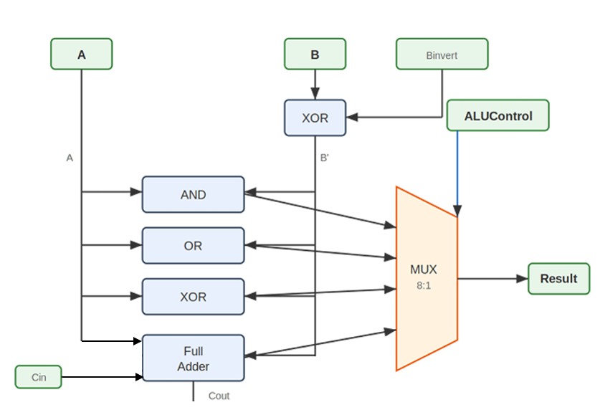
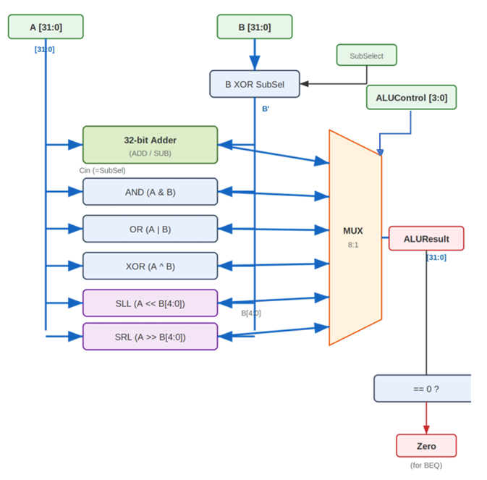

Comments

Task 2

Modules + Testbench:
Toplevelmodule:
`timescale 1ns / 1ps
//////////////////////////////////////////////////////////////////////////////////
// Company:
// Engineer:
//
// Create Date: 02/26/2026 10:56:10 AM
// Design Name:
// Module Name: toplevelmodule
// Project Name:
// Target Devices:
// Tool Versions:
// Description:
//
// Dependencies:
//
// Revision:
// Revision 0.01 - File Created
// Additional Comments:
//
//////////////////////////////////////////////////////////////////////////////////

module toplevelmodule(
input clk,
input reset,
input [15:0] switches_in,
output [15:0] leds_out
);

wire [31:0] op_A=32'h10101010;
wire [31:0] op_B=32'h01010101;

wire [31:0] switchess;
switches s1(.clk(clk), .rst(reset), .btns(16'b0), .switches(switches_in), .readEnable(1'b1), .writeData(32'b0), .writeEnable(1'b0), .readData(switchess) );
//alucontrol fot lower 4 switches
wire [3:0] control;
assign control = switchess[3:0];

wire op_clean;
debouncer u1(.clk(clk), .pbin(switches_in[4]), .pbout(op_clean) );

wire [31:0] result;
wire zero_flag;
ALU_module u2(.A(op_A), .B(op_B), .ALUControl(control), .ALUResult(result), .zero(zero_flag) );

wire [31:0] ledss;
leds l1(.clk(clk), .rst(reset), .btns(16'b0), .writeData(result),.writeEnable(1'b1),.readEnable(1'b0), .memAddress(30'b0), .switches(16'b0), .readData(ledss) );
// wire display=switchess[4];
// wire [15:0] display_data = (display) ? ledss[31:16] : ledss[15:0];

assign leds_out = (op_clean)? ledss[31:16] : ledss[15:0];
endmodule

switches:
`timescale 1ns / 1ps
module switches(
input clk,
input rst,
input [15:0] btns,
input [15:0] switches,
input readEnable,
input [31:0] writeData,
input writeEnable,
output reg [31:0] readData
);

always @(posedge clk) begin
if (rst)
readData <= 32'b0;
else
readData <= {16'b0, switches};
end

endmodule

leds:
`timescale 1ns / 1ps

module leds(
input clk,
input rst,
input [15:0] btns,
input [31:0] writeData,
input writeEnable,
input readEnable,
input [29:0] memAddress,
input [15:0] switches,
output reg [31:0] readData
);

always @(posedge clk or posedge rst) begin
if (rst)
readData <= 32'b0;
else if (writeEnable)
readData <= writeData;
end

endmodule

debouncer:
`timescale 1ns / 1ps
//////////////////////////////////////////////////////////////////////////////////
// Company:
// Engineer:
//
// Create Date: 02/19/2026 10:21:59 AM
// Design Name:
// Module Name: debouncer
// Project Name:
// Target Devices:
// Tool Versions:
// Description:
//
// Dependencies:
//
// Revision:
// Revision 0.01 - File Created
// Additional Comments:
//
//////////////////////////////////////////////////////////////////////////////////

module debouncer(
input clk,
input pbin,
output reg pbout
);
reg [19:0] counter=0;
reg sync_0=0;
reg sync_1 = 0;

always @(posedge clk) begin
sync_0 <= pbin;
sync_1 <= sync_0;
end

always @(posedge clk) begin
if(pbout==sync_1)
counter <= 0;
else begin
counter <= counter + 1;
if (counter == 20'hFFFFF) begin
pbout <= sync_1;
counter <= 0;
end
end
end

endmodule

ALU_moduke:
`timescale 1ns / 1ps
//////////////////////////////////////////////////////////////////////////////////
// Company:
// Engineer:
//
// Create Date: 02/26/2026 09:43:45 AM
// Design Name:
// Module Name: ALU_module
// Project Name:
// Target Devices:
// Tool Versions:
// Description:
//
// Dependencies:
//
// Revision:
// Revision 0.01 - File Created
// Additional Comments:
//
//////////////////////////////////////////////////////////////////////////////////

module ALU_module(
input [31:0]A, input [31:0]B,
input [3:0] ALUControl,
output reg [31:0]ALUResult,
output zero
);

always @(*) begin
if (ALUControl == 4'b0000) ALUResult <= A+B;
else if (ALUControl == 4'b0001) ALUResult <= A-B;
else if (ALUControl == 4'b0010) ALUResult <= A&B;
else if (ALUControl == 4'b0011) ALUResult <= A|B;
else if (ALUControl == 4'b0100) ALUResult <= A^B;
else if (ALUControl == 4'b0101) ALUResult <= A<<B[4:0];
else if (ALUControl == 4'b0110) ALUResult <= A>>B[4:0];
else ALUResult <= 32'b0;

end

assign zero = (ALUResult==0);

endmodule

testbench:
`timescale 1ns / 1ps
//////////////////////////////////////////////////////////////////////////////////
// Company:
// Engineer:
//
// Create Date: 02/26/2026 10:02:03 AM
// Design Name:
// Module Name: testbench_task2
// Project Name:
// Target Devices:
// Tool Versions:
// Description:
//
// Dependencies:
//
// Revision:
// Revision 0.01 - File Created
// Additional Comments:
//
//////////////////////////////////////////////////////////////////////////////////

module testbench_task2();
reg [31:0] A;
reg [31:0]B;
reg [3:0] ALUControl;
wire[31:0] ALUResult;
wire zero;

ALU_module alu(A,B, ALUControl, ALUResult, zero);

initial begin
A = 32'd5;
B = 32'd3;
ALUControl = 4'b0000;
#10;

A = 32'd10;
B = 32'd3;
ALUControl = 4'b0001;
#10;

A = 32'd2;
B = 32'd3;
ALUControl = 4'b0010;
#10;

A = 32'd2;
B = 32'd3;
ALUControl = 4'b0011;
#10;

A = 32'hAAAAAAAA;
B = 32'h55555555;
ALUControl = 4'b0100;
#10;

A = 32'd1;
B = 32'd4; // Shift by 4
ALUControl = 4'b0101;
#10;

A = 32'h00001000;
B = 32'd4; // Shift by 4
ALUControl = 4'b0110;
#10;

A = 32'd5;
B = 32'd5;
ALUControl = 4'b0001; // SUB
#10;
$finish;
end
endmodule

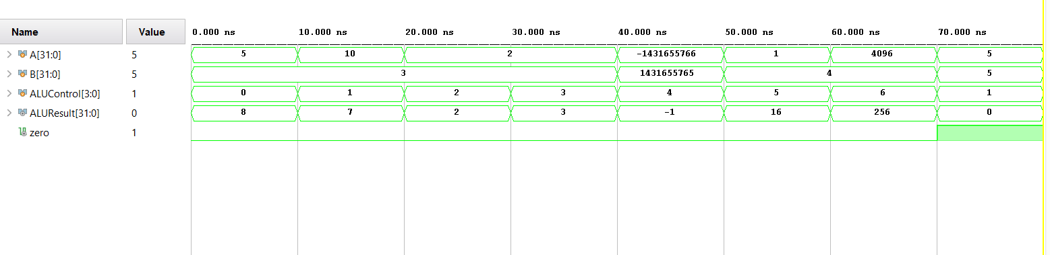

Results:
# | Op | A | B | Control | Result | Zero | Expected
1 | ADD | 5 | 3 | 0000 | 8 | 0 | 8, Zero=0
2 | SUB | 10 | 3 | 0010 | 7 | 0 | 7, Zero=0
3 | AND | 0xF0F0F0F0 | 0x0FF00FF0 | 0011 | 0x0FF000F0 | 0 | 0x0FF000F0, Zero=0
4 | OR | 0x0F0F0F0F | 0xF0F0F0F0 | 0100 | 0xFFFFFFFF | 0 | 0xFFFFFFFF, Zero=0
5 | XOR | 0xAAAAAAAA | 0x55555555 | 0101 | 0xFFFFFFFF | 0 | 0xFFFFFFFF, Zero=0
6 | SLL | 1 | 4 | 0110 | 16 | 0 | 16, Zero=0
7 | SRL | 0x1000 | 4 | 0111 | 0x100 | 0 | 0x100, Zero=0
8 | Zero | 5 | 5 | 0010 | 0 | 1 | 0, Zero=1

Task 3

RTL Schematics
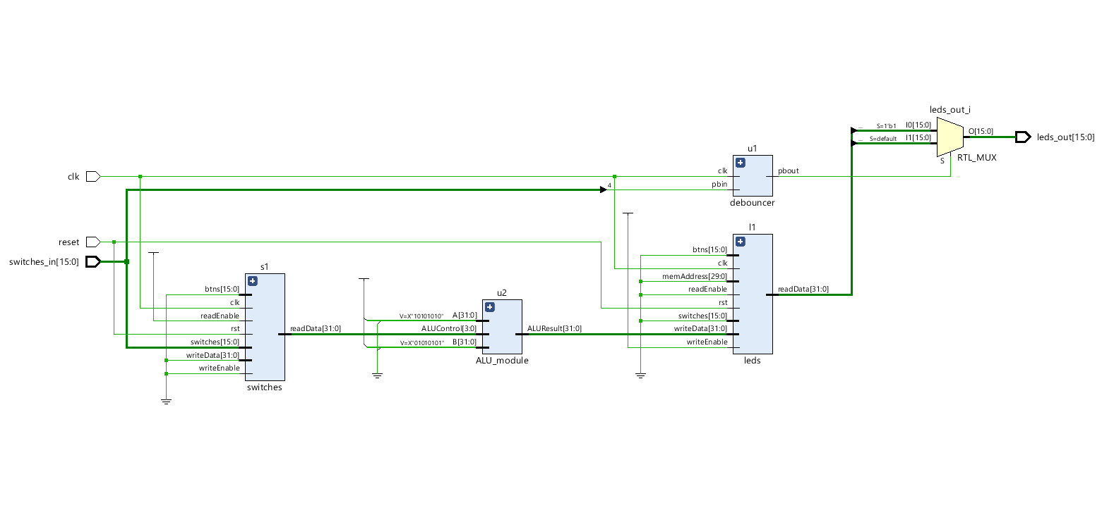

Lab 05 – Designing FSM Using FPGA Switches and LEDs

Assessment Rubrics

Points Distribution
Task No. | LR2  Code | LR 5  Results | LR11  Design | AR7
Task 1 | - | - | /20 | /20
Task 2 | /20 | /15
Task 3 | /10 | /15
Total Points | /80 |  |  | /20
CLO Mapped | CLO 1
For description of different levels of the mapped rubrics, please refer the provided Lab Evaluation Assessment Rubrics and Affective Domain Assessment Rubrics.
# | Assessment Elements | Level 1: Unsatisfactory  Points 0-1 | Level 2: Developing  Points 2 | Level 3:Good  Points 3 | Level 4:Exemplary  Points 4
LR2 | Program/Code/ Simulation Model/ Network Model | Program/code/simulation model/network model does not implement the required functionality and has several errors. The student is not able to utilize even the basic tools of the software. | Program/code/simulation model/network model has some errors and does not produce completely accurate results. Student has limited command on the basic tools of the software. | Program/code/simulation model/network model gives correct output but not efficiently implemented or implemented by computationally complex routine. | Program/code/simulation /network model is efficiently implemented and gives correct output. Student has full command on the basic tools of the software.
LR5 | Results & Plots | Figures/ graphs / tables are not developed or are poorly constructed with erroneous results. Titles, captions, units are not mentioned. Data is presented in an obscure manner. | Figures, graphs and tables are drawn but contain errors. Titles, captions, units are not accurate. Data presentation is not too clear. | All figures, graphs, tables are correctly drawn but contain minor errors or some of the details are missing. | Figures / graphs / tables are correctly drawn and appropriate titles/captions and proper units are mentioned. Data presentation is systematic.
AR9 | Report | All the in-lab tasks are not included in report and / or the report is submitted too late. | Most of the tasks are included in report but are not well explained. All the necessary figures / plots are not included. Report is submitted after due date. | Good summary of most the in-lab tasks is included in report. The work is supported by figures and plots with explanations. The report is submitted timely. | Detailed summary of the in-lab tasks is provided. All tasks are included and explained well. Data is presented clearly including all the necessary figures, plots and tables.

